**SIGEO-CTFS meteorological monitoring METADATA**

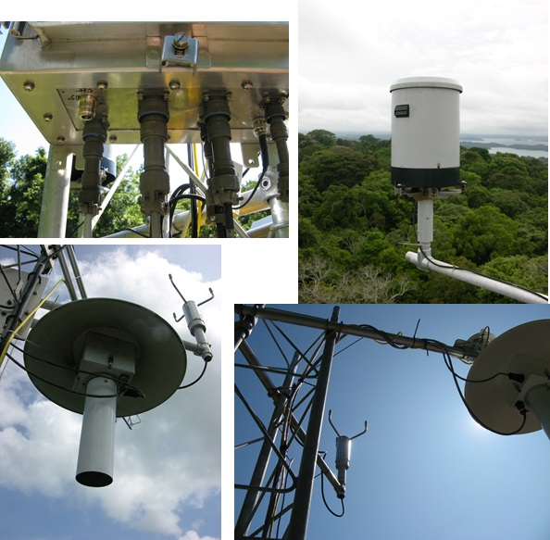

The SIGEO-CTFS stations comprise several sensors recorded automatically by a CR1000 datalogger (Campbell Scientific) at 5 min time interval. These sensors include:

1. Aspirated and shield temperature and relative humidity sensor plus an additional secondary temperature sensor (MetOne Instruments)
2. 2-D sonic anemometer WS425 (Vaisala)
3. Tipping rain bucket TB4-L (Campbell Scientific)
4. Solar radiometer CMP11 (Kipp&Zonen), plus a secondary radiometer LI-290 (LiCOR biogeoscience)

Data are available in comma separated format after passing a supervised QA/QC. We produce a new file for each year and each station with name XXX_metdata_5min_yyyy.csv, where XXX is a three code site identificator and yyyy is the year.

|  |  |  |  |
| --- | --- | --- | --- |
| **Variable** | **Unit** | **5-min stat** | **Description** |
| TIMESTAMP | TS |  | time in the format mm/dd/yyyy HH:MM |
| RECORD | RN |  | record number |
| RadTot_KZ_Avg | W/m2 | Avg | Solar Radiation Kipp&Zonen |
| RadTot_KZ_Std | W/m2 | Std | Solar Radiation Kipp&Zonen |
| RadTot_Li_Avg | W/m2 | Avg | Solar Radiation LiCOR |
| RadTot_Li_Std | W/m2 | Std | Solar Radiation LiCOR |
| T_Air1_Avg | C | Avg | Air Temperature sensor 1 |
| T_Air1_Std | C | Std | Air Temperature sensor 1 |
| T_Air2_Avg | C | Avg | Air Temperature sensor 2 |
| T_Air2_Std | C | Std | Air Temperature sensor 2 |
| RH_Avg | % | Avg | Relative humidity |
| RH_Std | % | Std | Relative humidity |
| WS_WVc(1) | m/s | WVc | mean horizontal wind speed |
| WS_WVc(2) | deg | WVc | wind direction |
| WS_WVc(3) | deg | WVc | Std wind direction |
| u_Avg | m/s | Avg | Mean wind in the u direction |
| v_Avg | m/s | Avg | Mean wind in the v direction |
| Prec_Tot | mm | Tot | precipitation |
| Resis1_Avg | Ohm | Avg | Resistance of temp sensor |
| Resis1_Std | Ohm | Std | Resistance of temp sensor |
| Resis2_Avg | Ohm | Avg | Resistance of temp sensor |
| Resis2_Std | Ohm | Std | Resistance of temp sensor |
| Asp_Fan_Avg |  | Avg | Number of fan cycles |
| BattV_Avg | V | Avg | Battery voltage |
| Tbox_Avg | C | Avg | Datalogger temperature |
| Batstat_Avg |  | Avg | Battery status (1 above 12V, 0 below 12V) |

**SIGEO-CTFS meteorological monitoring**

In 2009 SIGEO-CTFS started its own meteorological program. Four standardized stations were built in collaboration with Bill Munger (Harvard University) and installed closed to four CTFS plots: SCBI, KHC, HKK and BCI. The SIGEO-CTFS stations comprise several sensors recorded automatically by a CR1000 datalogger (Campbell Scientific) at 5 min time interval. These sensors include:

1. Aspirated and shield temperature and relative humidity sensor plus an additional secondary temperature sensor (MetOne Instruments)
2. 2-D sonic anemometer WS425 (Vaisala)
3. Tipping rain bucket TB4-L (Campbell Scientific)
4. Solar radiometer CMP11 (Kipp&Zonen), plus a secondary radiometer LI-290 (LiCOR biogeoscience)

We recognize that meteorological data are crucial information to understand how forest ecosystems work and how they respond to a changing environment. The data are intended to be freely accessible to all the CTFS community trought the CTFS website and constitutes a first step toward a wider meteorological program that will involve potentially all the network of sites.

Metadata and other information are available here.